LAKE MINTERWOOD BEACH CLUB NEWSLETTER – JUNE 2015
PO Box 311, Vaughn, WA 98394 www.lakeminterwoodbeachclub.org

Annual Kids Fishing Derby June 6, 2015

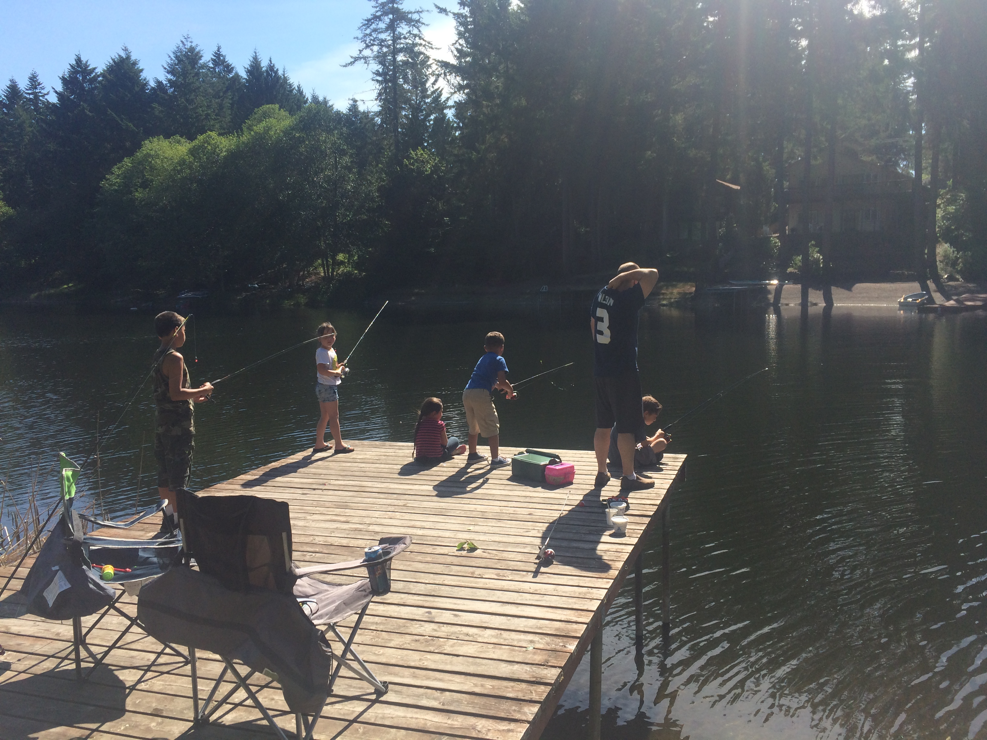
The scene at the fishing dock

Twenty-seven kids, aged 0-14, registered to compete in the hour-long derby. Prizes were awarded for first fish, longest fish and heaviest fish. All children who attended were given a goody bag and take home prizes.

Prize Winners: (age in ( ) )
First fish: Izabelle (4), Arieanna (5), Jojo (11)
Longest/heaviest fish:
Ryder (3) 20.75 in 2.75 lbs,
Maris (9) 20 in 2.75 lbs,
Adrianna(8) 19.5 in 2.5 lbs,
Chloe(7) 19.5 in 2 lbs

Others who caught fish:
Ethan, Joe, Westen, Rueben, and Sofia.

Thank you to all that participated in planning and set up/tear down, buying prizes, and providing good snacks.
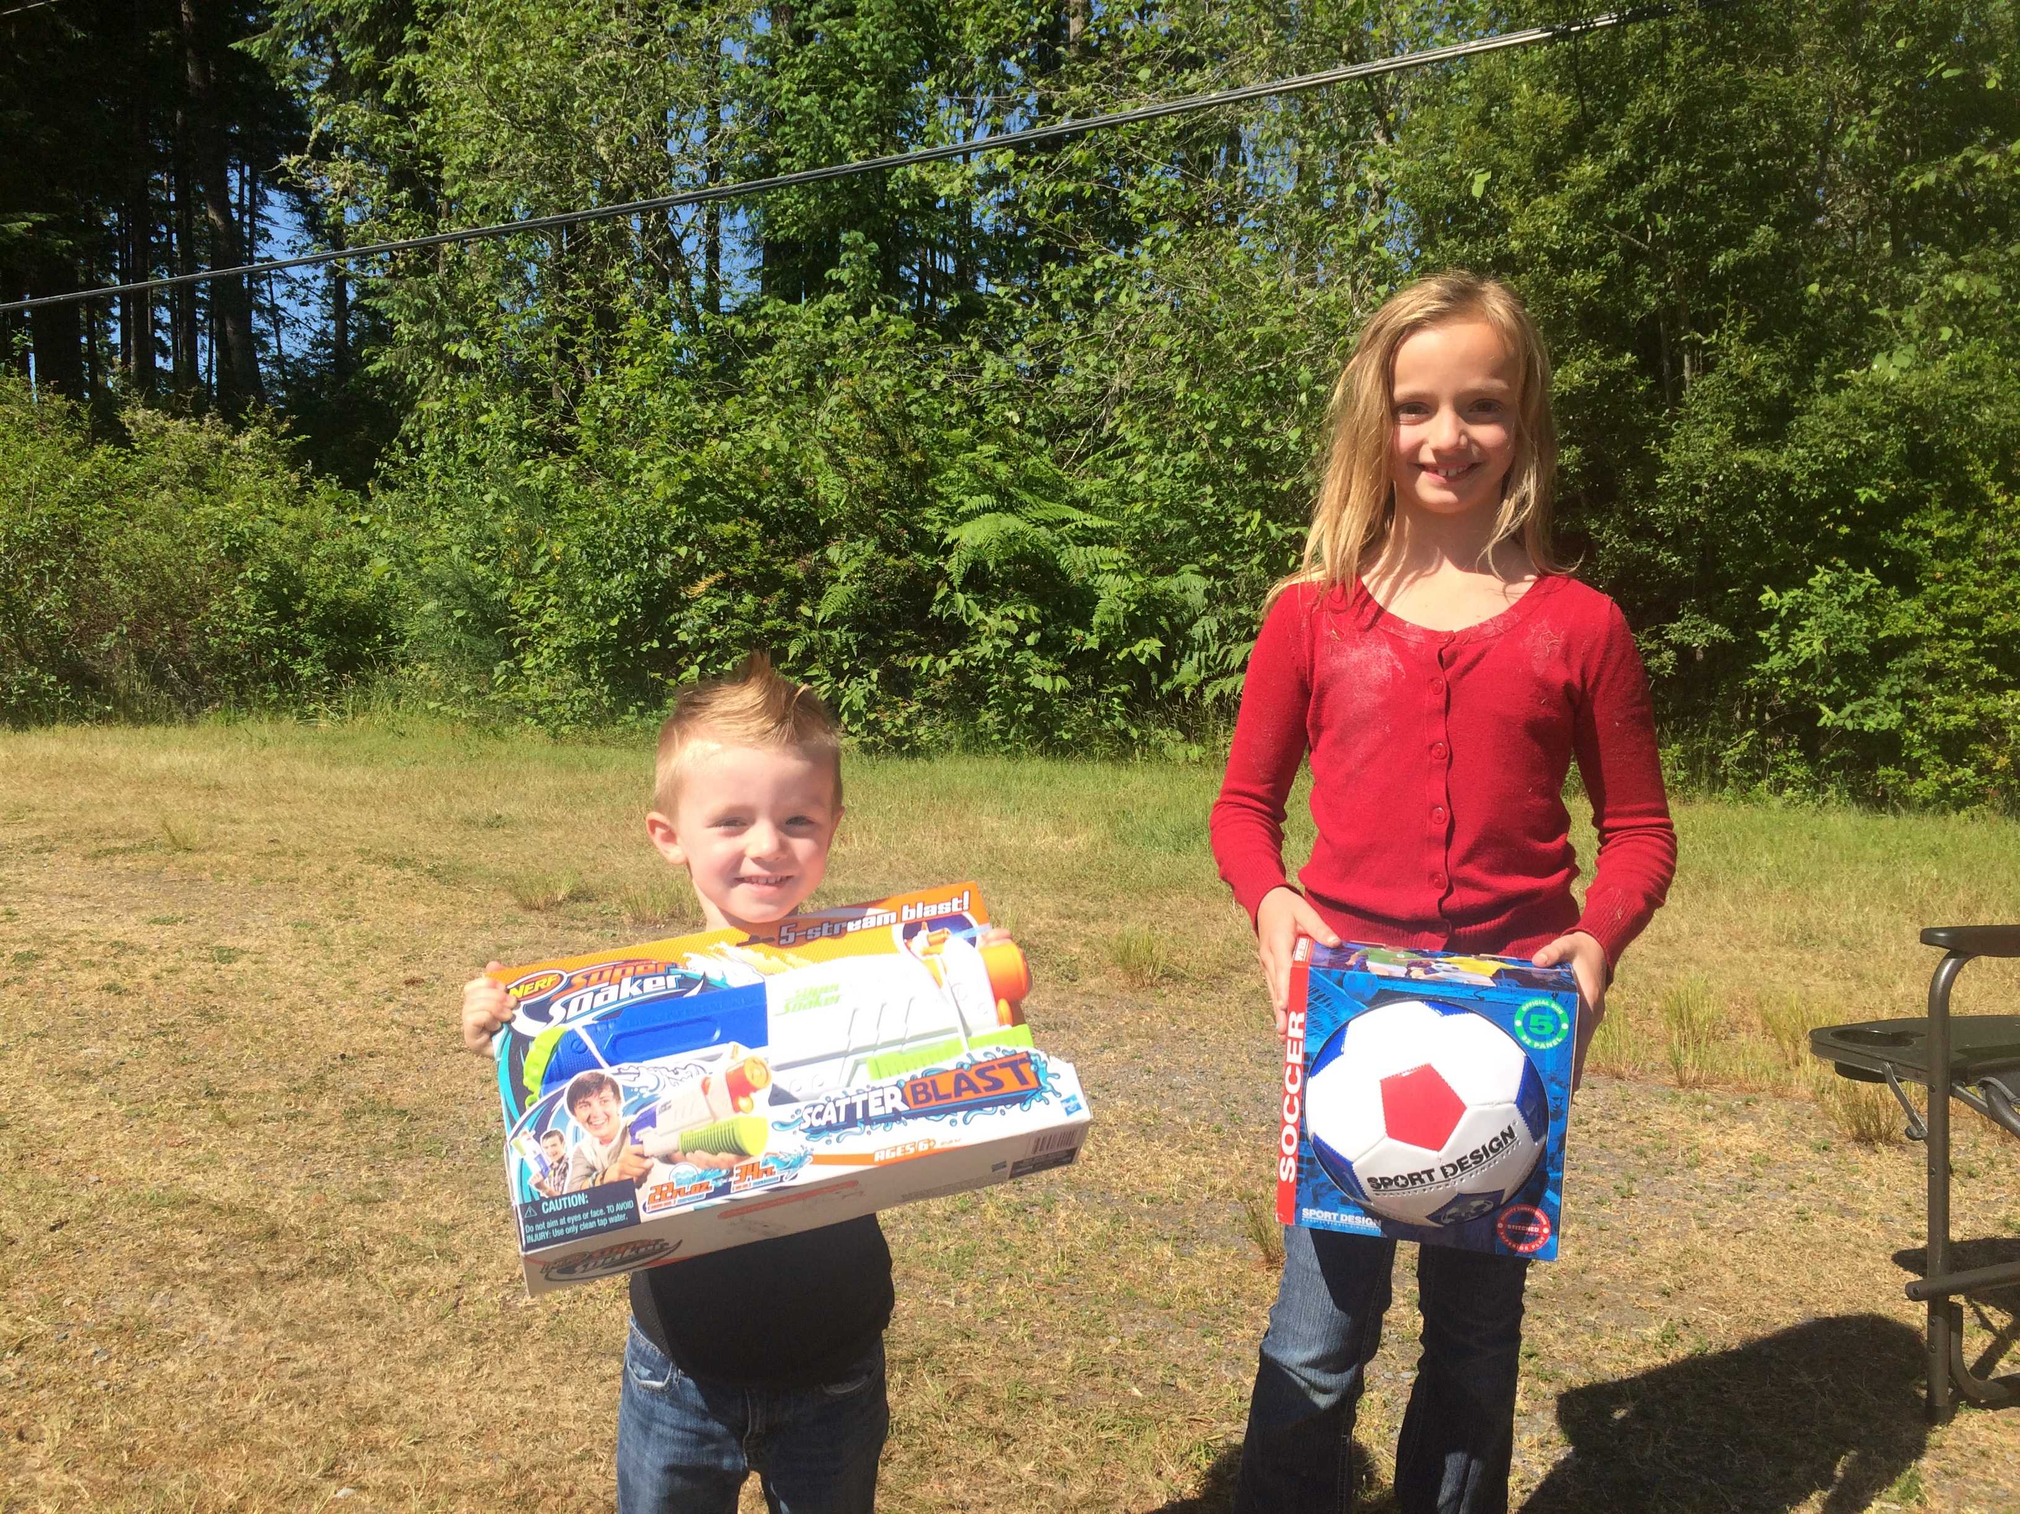
The winners: Ryder (3) & Maris (9) with prizes

NEW PLAYGROUND EQUIPMENT

New playground equipment has been ordered. It features a corkscrew slide, several climbing areas, a twister element, etc. over a base of engineered wood fiber (cedar chips) about a foot deep. It is ADA compliant, designed for kids 5-12 years old, yet is usable by younger children under adult supervision.

To see a diagram of the new playground, visit the lakeminterwoodbeachclub.org website and click on “recent news,” then June 17th Highlights.

By way of background, upgrading our current playground has been under consideration for some time. The current playground apparatus has been around for 25 or more years and is not up to current standards. The trustees formed a Playground Committee headed by Robyn McGilvrey. The committee surveyed the membership via an on-line questionnaire(receiving many responses), visited newer local playgrounds and contacted vendors of such equipment. The committee brought forth concepts from two vendors: Playcreation/Landscape Structures in Burien, WA and Northwest Playground Equipment in Issaquah, WA. Both proposals cost approximately $30,000. While the committee made no specific recommendation to the board of trustees, Play Creation’s concept was preferred unanimously by those LMBC members at the annual meeting and by the full board of trustees. LMBC’s accumulated reserves will pay for this project.

To save us money, community volunteers will install the playground equipment directed by a Play Creations supervisor. Some 25 volunteers will be needed. Please contact Robyn McGilvrey at 253- 225-6485 to sign up.

The schedule:
✪ Saturday, July 18th (with Saturday July 25th as a backup): remove present structure and grade the area flat.

✪ Saturday, July 25th: footings will be poured.

✪ Saturday, August 1st Main build day. This is when we need the most help.

✪ Sunday, August 9th: Dedication. The new playground will be dedicated in conjunction with Lake Minterwood’s community picnic and games.

FIREWORKS ONLY ON JULY 4TH

The board of trustees has prohibited discharge of fireworks on LMBC property except on Saturday, July 4th.

This prohibition applies to the beach area, the fishing bank and the dam. It’s a matter of safety for kids and adults, the danger of igniting fires under current dry conditions, the amount of fireworks debris, and adult supervision.

Comply with Pierce County’s restrictions on discharging fireworks. The LMBC does not sanction illegal fireworks. Only WA State approved consumer 1.4G “common” fireworks are permitted. These are the “safe and sane” fireworks. NOTE: Bottle rockets are illegal in WA State. Don’t let your kids use these! Bottle rockets are attached to 12” sticks for “guidance.” The fire department says bottle rockets cause lots of fires.

IF YOU SHOT FIREWORKS OR ENJOYED THEM, HELP CLEAN UP THE BEACH AND DAM AREA BEGINNING AT 9:00 am July 5th

Community Garage Sale JULY 17 - 19

Again this year, LMBC will sponsor a community-wide garage sale in Lake Minterwood. The LMBC will publicize the sale in local papers and will place signs. There’s no central location. Hold your own sale or combine with other families. Free or for sale items are to be left curbside only Friday through Sunday.

Community Picnic – Sunday August 10th

For this year’s picnic, the LMBC will provide a roast pig for pulled pork BBQ sandwiches as well as hot dogs and beverages. Bring a side dish to share for this pot-luck. Games (on land and in water) will start at 3 pm. Food will be ready about 4 pm, AND WE’LL DEDICATE THE NEW PLAYGROUND. Come and enjoy a fun Sunday afternoon with your neighbors!

New Life Jackets Purchased These are now available for your kid’s use. Please return them to the rack after use.

Picnic Area Reservations To reserve the picnic shelter, download the reservation form from LMBC’s website and contact Robyn McGilvrey at 225-6485 to finalize arrangements.
LMBC Website
Have you visited LMBC’s updated website lately? It’s the primary means whereby the board of trustees communicates to members. Highlights of board meetings are posted on the website shortly after the meeting. The website provides ready access to LMBC Covenants, Bylaws, ACC Forms, etc., has current and past newsletters, a “latest news” section and “lost and found” sections. For the convenience of members, it is planned to add a search feature to the website. Check in often at lakeminterwoodbeachclub.org for the latest.

Fishing Rules & Reminders
Only members with current membership identification cards have fishing privileges. Catch limit is 4 fish/day per authorized fisherman. Each fisherman is allowed one pole at a time.
Members must accompany their guests.
Each lot owner is allowed a max of 4 fishing guests at any one time at no additional charge. Members may purchase a maximum of 10 one-day fishing passes for a $5.00 each. Contact Robyn McGilvrey, 225-6485, for extra passes.

Your Feedback Your Board of Trustees appreciates feedback -- comments, suggestions, complaints (must be in writing), even praises! Write to LMBC, P.O. Box 311, Vaughn, WA 98394 or go to meetings held at 7:00 p.m. at the Library on the 3rd Wednesdays of the month.

School’s Out Please drive slowly watching out for kids playing in the streets.

Walking in Lake Minterwood Walking is good almost any time here, especially in cooler mornings or evenings. So how far are you walking? Print out the walking map from our website:
Lakeminterwoodbeachclub.org.

Annual Dues Statements Dues statements ($240) will be mailed about July 20th. Dues are delinquent if not paid by October 1, 2015. Please pay promptly by check or visit the LMBC website to use Paypal if you wish to use a credit or debit card. If you use Paypal, your payment amount is $247.26. The extra $7.26 is a transaction fee charged to LMBC by Paypal because you used a credit or debit card to pay your dues. If you cannot pay in full at one time, please contact Felice Capone at 253-884-2934 to arrange a payment plan. Upon payment, you’ll receive new LMBC cards with new gate and beach house combos.

Architectural Control Comm. Reminders

All Lake Minterwood property owners must get approval from the ACC before cutting trees and before making any modifications to buildings or property including, but not limited to: erecting fences over 4 feet high; painting or repainting houses and sheds; replacing roofs; clearing land to install septic systems; or building docks, houses, house extensions, sheds, garages; and other structures. You need an ACC permit even if you already have a permit from Pierce County. Same for renters! Call any board member for an ACC Permit Form or download the form at the LMBC website, www.lakeminterwoodbeachclub.org. Mail it to LMBC. The ACC acts promptly. Questions? Call 303-0813 or 313-0299.

Temporary Structures

LMBC’s Covenants and Conditions, Article II, Section 2 states: “Temporary structures such as tents, travel trailers, or other out buildings may be maintained upon a lot only during the period of construction of a permanent dwelling thereon, and in any event no longer than nine months. Any other structures or quarters, not permanent in nature, must be removed upon demand of the [Architectural Control] Committee. No house trailer or mobile home shall be permitted within the Lake Minterwood plat.”

In particular, this prohibition applies to the tent-like canvas covered or canvas enclosed structures used as carports or boat sheds.

Yard and Property Appearance

Summer’s a good time to do needed cleanup. Our covenants state: “Each lot shall be maintained in a clean, sightly condition at all times and be kept free of litter, junk, containers, equipment and building materials.” “Garbage containers shall be kept concealed from view.”

Please park cars in driveways not on lawns. Keep street fronts clean and weed wacked. A neat neighborhood helps increase home values. If you were selling your property, you’d want that.

Fire Hydrant Intakes Extended

Trustee Rick Anderson installed extensions on the intakes to two hydrants to ensure lake water access when the lake level is lower as now due to lack of rain and higher evaporation. Thanks Rick!
Lake Minterwood Board Directory

President
Robyn McGilvrey | 253-225-6485
Secretary ♦ Treasurer
Bob DeLaney | 253-884-6469
Lake Management
Robin Harvey | 253-884-3623
Bob Sandquist | 253-884-7738
ACC
Judy Scott  Ellie Klauminzer | 253-303-0813  253-313-0299
LMBC Facilities
Rick Anderson | 253-426-2653
David Dowling | 253-225-8732
Security ♦ Safety
Randy Vint | 253-225-6106
Social
Robyn McGilvrey | 253-225-6485

You Make the 911 Call
In threatening or emergency situations, YOU MAKE THE 911 CALL. Don’t expect a board member to do it for you. You can notify the board and/or make a Facebook posting later.

➔To report vandalism or suspicious situations:
Call Pierce County Sheriff, 798-4721, option 1

➔Power outages: Call Pen. Light, 857-5950

Goodwill and Welcome Committee

New owner or renter in Lake Minterwood or know someone who is? We want to welcome you! Please call Anne DeLaney, 884-6469 or Judy Scott, 303-0813.

Lake Minterwood Beach Club
P.O. Box 311
Vaughn, WA 98394-0311

